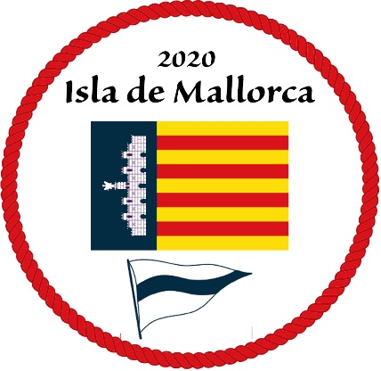
Oct 13, 2019
Hotels in Palma
While sailing activity has quieted down in September, it is a very popular time for hiking and biking and consequently there is strong demand for hotel rooms. When you have an idea on your travel plans, it is advisable to book now. While policies vary, typically the hotels will allow plans to be adjusted later. Prices quoted are for a double or twin including breakfast and are subject to prior sale or change. Generally greater discounts for early booking. Prices generally include VAT but not City Touristic Tax of 4.40€/person & night which is paid on departure.
Jock and I visited a number of hotels and following are a list we can recommend. We asked hotels for direct purchase pricing which saves them the 18% booking agency fee. The prices shown below reflect those discounts. You would think these prices would be better than through booking agencies but we have found that is not always the case. It is best to quietly compare the price offered through the agencies when booking.
Let us know where you have booked and issues you identify. We will try to keep this note updated with revisions posted to the CCA Mallorca event website.
B O Hotel - attractive modest 19 room boutique 4 star hotel very close (200 metres) to the La Longa marina. Located in a recently renovated 19th townhouse, all modern facilities. This will be the Macrae – Crane base for the event due to it’s proximity more than it’s price. CCA Price €240/ night for a Double Deluxe Room
Hotel Saratoga – attractive 4 star modern small hotel 0.4km N of LaLonja. Enter Disc code CCA from ~€ 160 / night. Probably the best value of this list. 2 blocks from ElCorte Ingles.
Nakar Hotel – modern very nice 57 room 4 star hotel on Ave de Jaume III 0.5km N of LaLonja. Next door to El Corte Ingles, a leading department store that has a very good food floor that is open Saturday 9:30 – 21:30 and Sunday at 11:00 – 20:30. It is the only major grocery store convenient to the marina that is open Sunday. Contact reservations@nakarhotel.com mention CCA and NKR PROMO for 5% discount and some free CAVA. Current net price ~ €235

Posada Terra Santa – recently renovated beautiful 19th century home, 19 rooms, 4 star, 1.3km ENE of LaLonja. Trip Advisor ranked # 1. A lot of character and quality, great value. They offer us a 12%discount in the best available rate, for all guests. Send an email to TOMÁS LÓPEZ manager@posadaterrasanta.com with the code CRUISINGAMERICA12% Current net price ~€235

Hotel Gloria – Beautiful luxury conversion of an old Palma mansion, 18 rooms, 5 star 1.1km NNE of LaLonga. Expensive but unique.
Summum Boutique Hotel – A beautiful 5 star conversion of the 15th century Ca'n Berga-Ladaria Palace, 18 rooms, 1.1km NNE of LaLonga. Luxury. Deluxe: 300€, Premium: 350€, Junior Suite 450€. Email info@hotelsummum.com attn Christina with the promo code Cruising Club of America. The prices include breakfast and are non-refundable. Worth the extra.

