Pacific Northwest Station of
The Cruising Club of America
Minutes of the Monthly Meeting of November 3, 2021

Our November meeting was called to order at 1238hrs at the Seattle Yacht Club by Rear Commodore Rick Meslang, fresh off a grueling ferry ride from the Olympic Peninsula. The meeting was also made available for virtual attendees by the resolute Susan Stillman who, in her usual and efficient way, provided Zoom links for remote speakers and participants alike.

In Attendance In Person: Rear Commodore Rick and Maureen Meslang, Vice Commodore Chris and Shawn Otorowski, Former Rear Commodore Gil Middleton, PNW Membership Chairman Dave Utley, Former Rear Commodore Doug Cole, Frederic Lafitte, Cruise Chairman Joe Golberg, Rum Meister Steve Jacobsen, Peter Powell, Robert Johnston, Michael Gropp, Former Rear Commodore Mike O’Byrne, Zoom Mistress Susan Stillman, Environment of the Sea Representative Charlie Stillman, Dan McDonough, Bill Nelson, Program Chair Suzette Connolly, Paul Baker, Alex Simanis and Elishia Van Luven, Guest Speaker Carl Sutter and Christina Sutter, Sue McNab, Tom and Kappy O’Brien, Carl Buchan, John Ellis (guest), Rusty Lhamon, Governor Roddy Hearne, Mike Brown, Station Historian John Kennell, Immediate Past Cruise Chairman John Pedlow, recent Vilas Literary Award winner Alan Forsythe, Richard Anderson, Brent and Jill Peterson, Roger Wheelis, Berit Kenin, Gary Nolan and Past Cruise Chairman Tom White.

In Attendance Virtually: Commodore Robert Medland, Safety and Seamanship Representative Mark Roye, Former Rear Commodore Sue Corenman, Jim Corenman, Ann and Jon Bowman, Jill and Rod Hearne, Pat Carey, Tim Carey (guest), Phil Swigard, Dan Schwartz, Baird Tewksbury, Sec/Treasurer Douglas Adkins and Membership Chairman Ernie Godshalk (BOS/PNW hon.),

(Please note that leadership positions recorded in the rollcall this month are an attempt to show the breadth of involvement and commitment of the members of “a club without a clubhouse”. Your Sec/Treas may have missed some titles and, if so, apologizes, but the point should be clear. A great deal of effort from a great many people keeps the Cruising Club of America healthy and vibrant. Thanks go to all.)

Rear Commodore’s Report:

Rear Commodore Meslang welcomed us all and invited the introduction of guests. He then asked Commodore Robert Medland, who attended virtually, to comment. Bob congratulated us noting the happy banter and the importance of a sailing life.

Monthly Committee Reports were asked for and given as follows:

Reports from Cruisers: Suzette Connolly reported that Sonny and Margie Stolsig on Hoptoad are in the San Diego area and will be heading to Mexico the middle of November. Scott and Mary Malone on Morningstar are also in San Diego and will be heading to Mexico soon.

Membership: PNW Membership Chairman David Utley introduced new members Brent Peterson and Alex Simanis, presenting them with their burgees and ties.

Finance: Secretary/Treasurer Doug Adkins reported that the PNW Station is financially solvent and, in a shameless political endorsement, stated that it will most likely be even more so when Susan Stillman is elected Treasurer at our annual dinner later in the month.

Historian’s Report; John Kennell brought us back to a unique Pacific Northwest event, the Sammamish Slough Hydroplane Races, beginning in the 1920’s with their hay-day in the 50’s and 60’s and continuing until 1976. The dangerous event for drivers and spectators alike was run in limited-class hydros and famous names in racing, including our own Dave Utley, were participants. The races were a fixture in the annual watersports calendar and John’s excellent report is attached.

Safety and Seamanship:
Mark Roye provided a Safety Moment report regarding the importance of Pollution Liability Insurance for all yacht owners, even if hull and other liability coverage is not maintained. The downside is significant, and Mark’s description of the outfitting of the clean-up and salvage tug Betty underscored the extensive cost and equipment needs in addressing a pollution event. His report is attached.

Cruise Report: Our newly appointed Cruise Chairman Joe Golberg outlined the initial planning for a Spring Cruise to Barkley Sound next year. It is expected to take place in late May or early June and advice was invited from those who have been in the Sound in recent years. The Fall Cruise remains uncertain but may include a venue closer to home.

Environment of the Sea: Charlie Stillman reported on a meeting of the Environment of the Sea Committee and announced the important new theme of Plastics and their threat to our oceans. The Committee is advancing protocols for the Club to be a leader in controlling plastic pollution by eliminating single use plastic at club events and focusing on re-usable utensils and dishes to avoid adding to the problem. More specific guidelines will follow.

Next Watch: Roddy Hearne reported that four Next Watch members were in attendance today and stated that a local committee is being formed for Next Watch events, including all members of course. He also urged people to look at the crew rosters of the Vic-Maui and TransPac races for candidates who might be potential CCA members.

Program Committee: Speaker Chair Suzette Connolly announced that our December speaker will be James Utzschneider and Jenna Miller talking about their circumnavigation on a catamaran with their kids. There is no speaker yet identified for January and ideas are being sought. Our February speaker will be Chris Roberts M.D who will discuss medical preparedness and first aid at sea.

Featured Speaker: Tom O’Brien introduced our Featured Speaker Carl Sutter. The history of yachting in the Pacific Northwest in closely intertwined with Carl and his family’s important maritime business Fisheries Supply. Carl regaled us with questions and stories of racing classes from Flatties to Stars to the big boats of the past. He recalled his growing up involved with the early family business Fidalgo Island Packing Company owned by his uncle. Carl also called on Jon Bowman to relate his experience in acquiring the Blanchard Boat Company. Delightful stories of crewing for Bill Buchan and an important mention of Bill’s recent book “Star Fever“ brought back memories of Pacific Northwest racing and the characters who made the region a sailing mecca. The book is available exclusively at Fisheries Supply and the proceeds from its sale go to the University of Washington sailing program. It was great fun for the Station to hear from Carl.

Closing;

R.C. Meslang reminded us of our Annual Dinner and Election to be held on Sunday, November 21st at the Seattle Yacht Club.

The meeting was adjoined at 1410 hours.

Respectfully submitted,

Douglas Adkins
CCA/PNW Secretary/ Treasurer

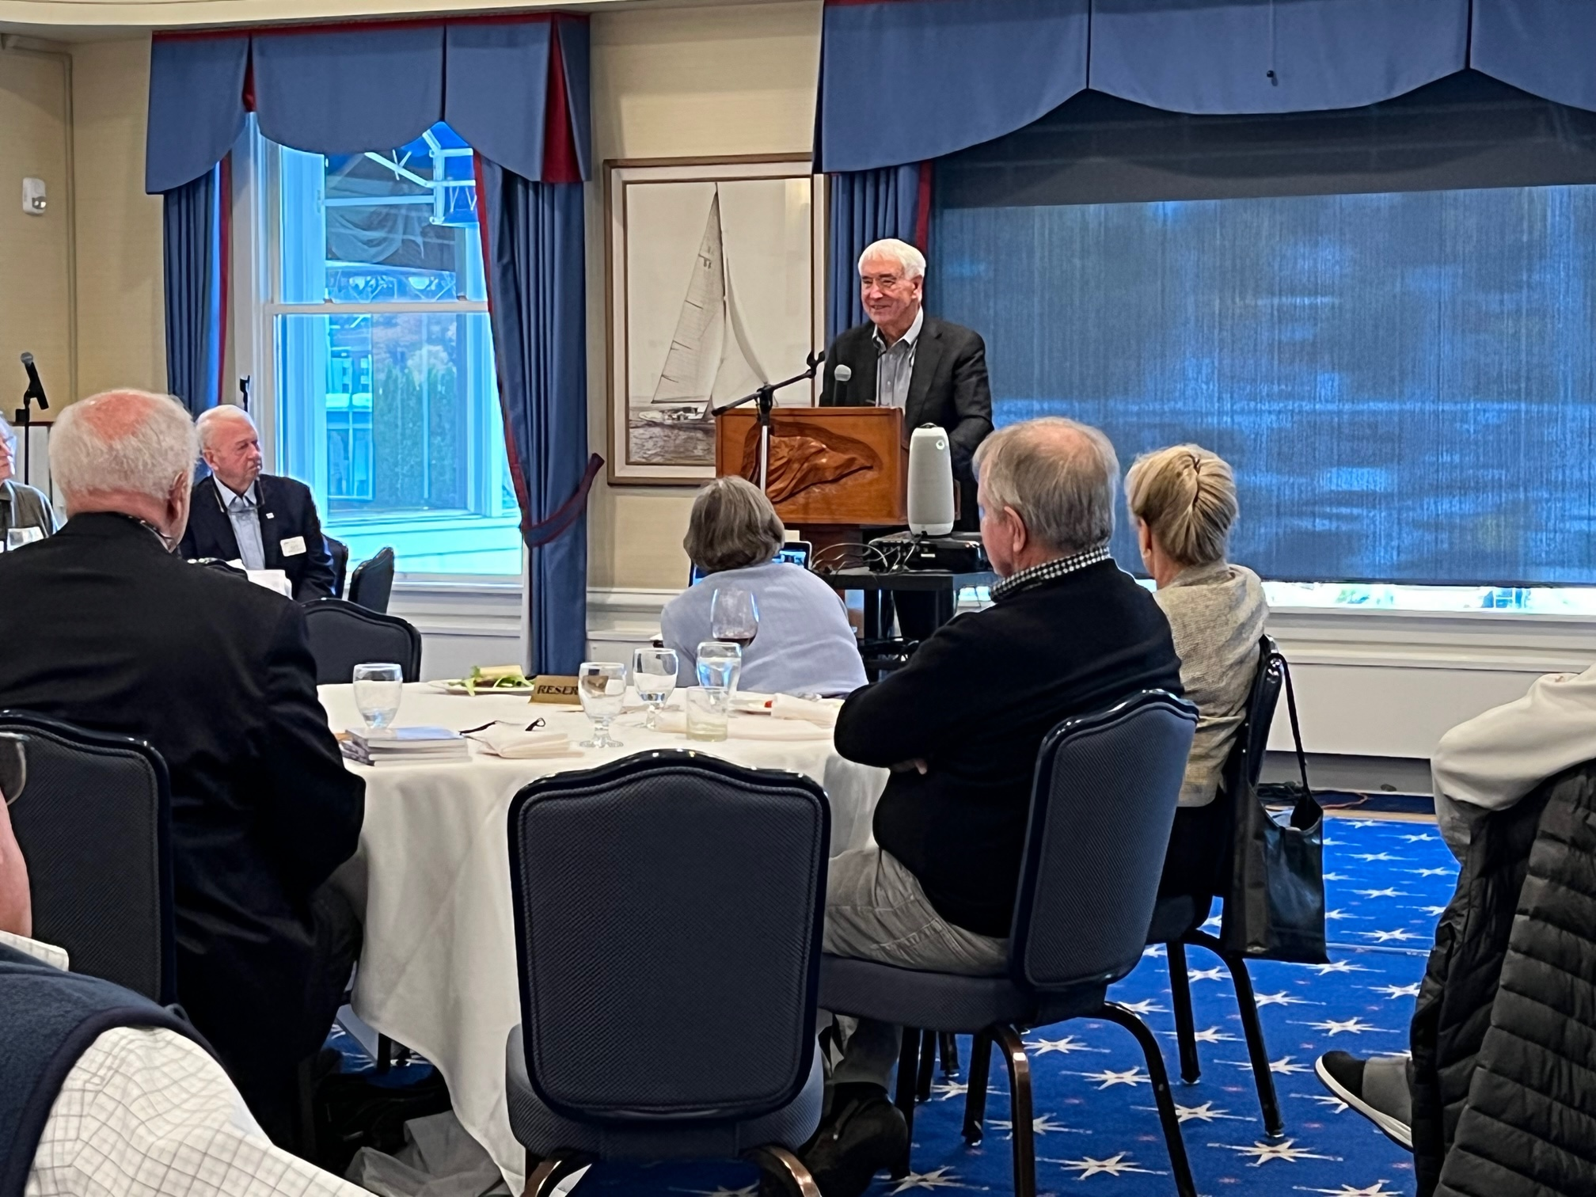
Carl Sutter addresses the Station (Doug Cole Photo)
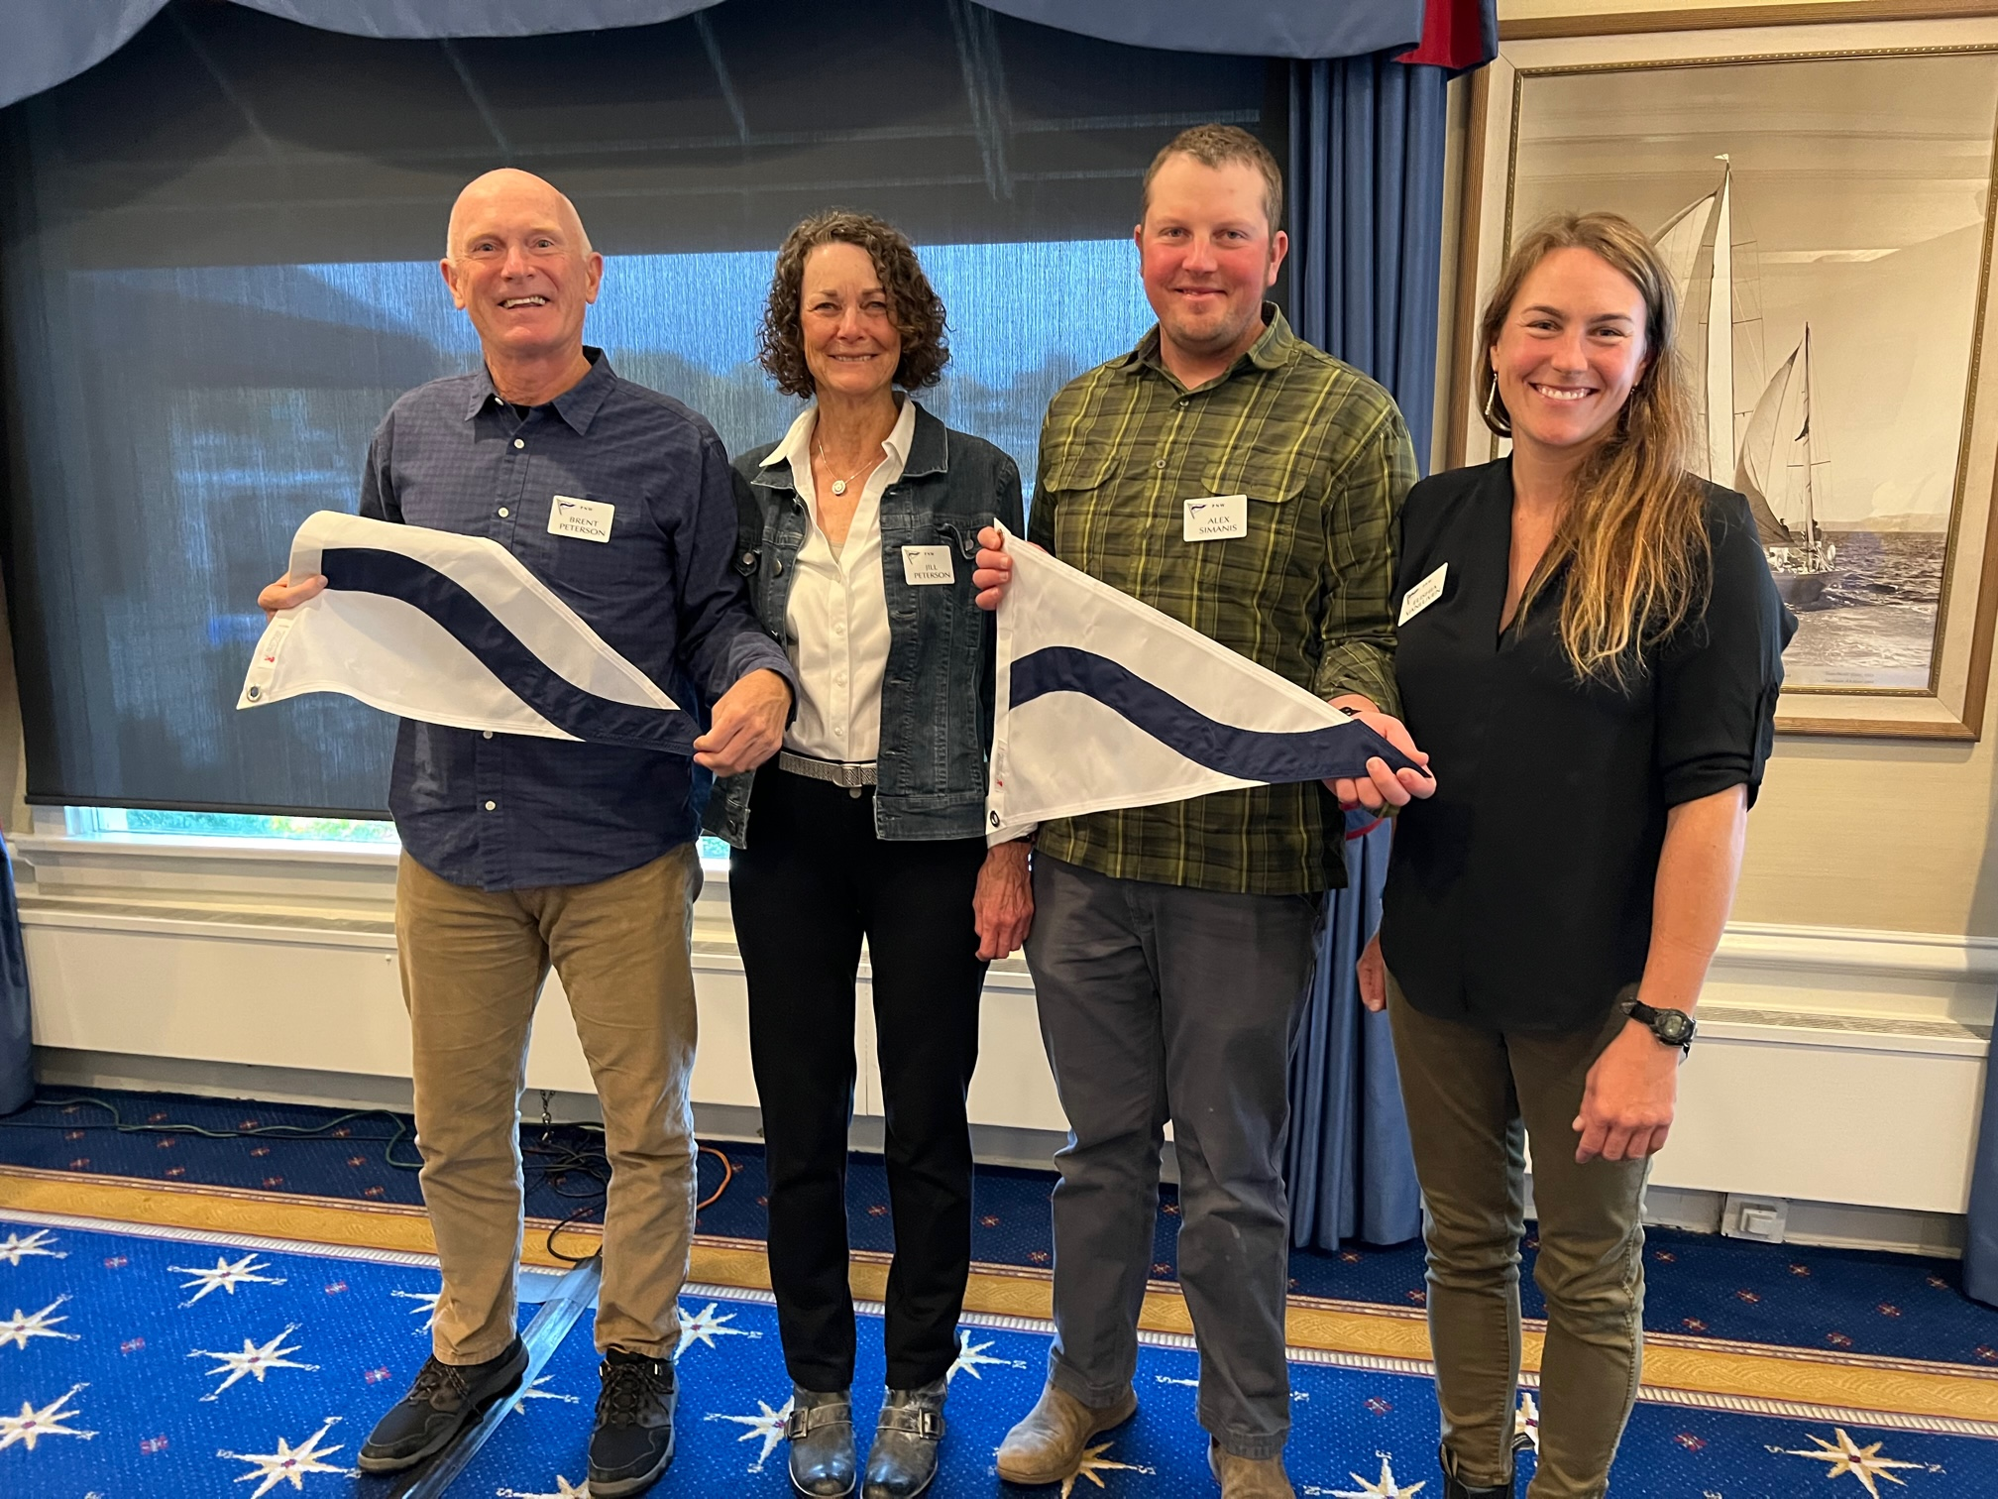
Brent and Jill Peterson, Alex Simanis and Alishia Van Luven, New Members
(Doug Cole Photo)

